Geographical data: How can digital technologies help increase accessibility and mobility for all?   
*Sébastien FROMENT[1], Cerema  
Laurent SABY[2], Cerema*

***Keywords :*** *Digital, Accessibility, Geographical information system, Smart city*

**Introduction**

In partnership with Grenoble Alpes Métropole, Lorient Agglomération and Toulouse Métropole, Cerema has been working to create a database model to describe the accessibility of the mobility chain in local authorities’ geographical information systems. The aims of this model are: to optimize the costs of data collection and management, to enable new services, such as pedestrian route calculations, to be developed, and to homogenize the information provided and its quality.

**Background**

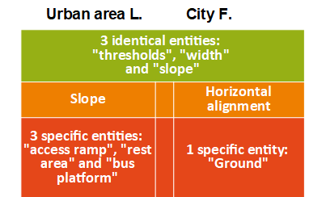

**Figure 1** Basic comparison between the descriptions of a pedestrian path in two existing models

Cerema, the French major public institution for developing and capitalising on public expertise in the fields of planning, regional cohesion, and ecological and energy transition, drew up in 2014 an inventory of digital tools and services, run by private and public stakeholders, designed to improve the mobility of people with disabilities or reduced mobility. The key findings are:

* There are only a few initiatives in France (around fifteen);
* As each initiative is service-oriented, there is a significant variability between systems : variation in user profiles, in covered areas, in type of services (static map, route calculation, in the form of an app or a website) and in the geometry of the data model;
* The data models are heterogeneous and, as a result, they do not make it possible to ensure interoperability between systems and applications in the long term.

The development of a common data model describing the accessibility of the travel chain, considered as the bone structure of any geographical service, therefore appeared as a necessity.

**Method / Design**

In partnership with Grenoble Alpes Métropole, Lorient Agglomération and Toulouse Métropole, Cerema has been working to create a database model to describe the accessibility of the mobility chain in local authorities’ geographical information systems. The aims of this model are:

* to optimise the costs of data collection and management;
* to enable the development of new services, such as pedestrian route calculations;
* to homogenise the information provided and its quality.

The ultime goal of this data model is to enable a wide-scale multimodal route calculation service that can provide personalized informations according to the user’s profile, including its disabilites.

The project was carried out in three phases:

* the first phase on the convergence of data from existing models in partner authorities;
* the second phase took the form of a workshop involving public and private stakeholders working on the subject;
* the third phase focused on the development of the conceptual model and the object catalogue.

The convergence of the data models has been done according to three principles:

1. To prioritize attributes based on the objective in figure 2;

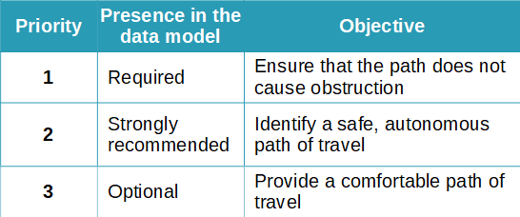

**Figure 2** Grid of objectives to prioritize attributes

2. To prefer objective data such as measurement over information, such as “accessible” or “not accessible”, to assure adaptability of the implemented data,

3. To focus on the notion of navigation path, to assure homogeneity in the characterisation of the three links of the mobility chain.

**Results**

The proposed data model is centered on the notion of navigation path and on the needs and difficulties of users with reduced mobility. It therefore characterized the three links of the mobility chain and their interfaces in the same way. The proposed data model reach approximatively 320 criteria distributed in 24 object classes.

**Conclusion**

This work is the first stage in the development of a standard exchange format for accessibility data. It paves the way for the development of new services for local authorities (diagnosis, planning and tracking of works) and will eventually make it possible to offer homogenized and appropriate services to all the diverse kinds of users.

1. [sebastien.froment@cerema.fr](mailto:sebastien.froment@cerema.fr), France
2. [laurent.saby@cerema.fr](mailto:laurent.saby@cerema.fr), France